
Royal University of Phnom Penh
Faculty of Science
Department of Computer Science

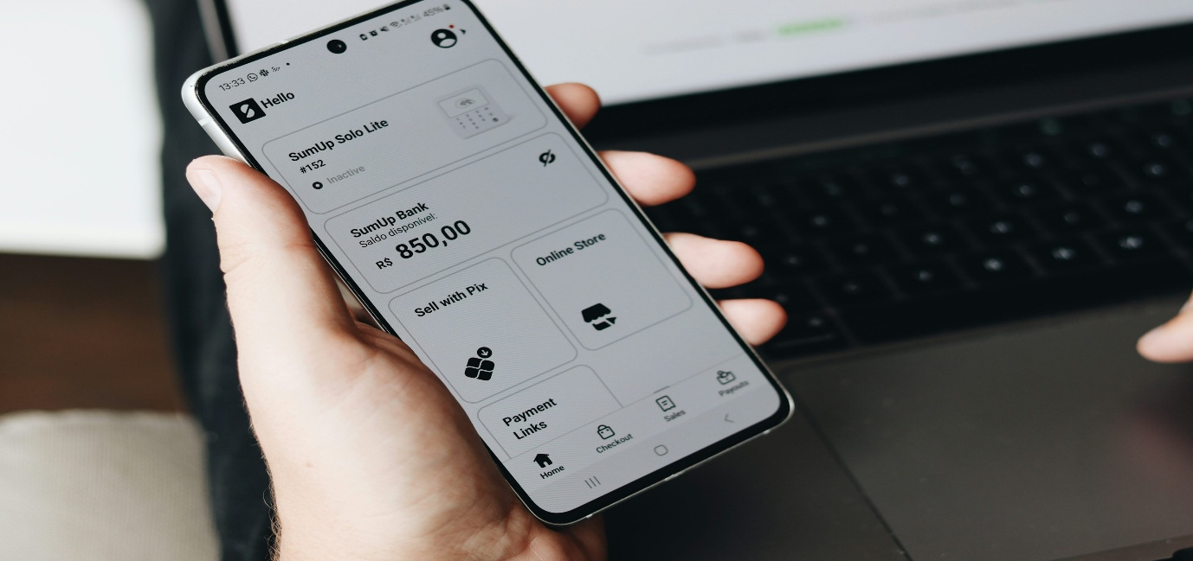
Topic: Financial Tracking App
Developed by:
- Ngorn Lika
- Rous Sokmuny
- Chamrong Raksa
- Seng Visal
Subject៖ Mobile Systems and App
Lecturer: Taing PengSreng
Class: A2 Year-4
Academic Year: 2025-2026

Introduction
In today's digital landscape, mobile apps are essential tools that allow individuals to manage daily activities, track finances, and retrieve information on the go. Creating top-tier applications, however, goes beyond mere programming skills; it requires tight-knit collaboration and the synergistic efforts of a multidisciplinary team striving for a shared goal.
This assignment centers on conceptualizing and developing a Mini Product Feature Module utilizing Flutter, a cutting-edge cross-platform framework designed for crafting robust mobile applications. With its extensive library of pre-configured widgets and robust support for UI/UX design, state management, and backend connectivity, Flutter stands out as an optimal solution for agile mobile development.
For this project, our group engineered a Financial Tracking App Module, specifically tailored to assist users in seamlessly managing their personal finances. The core capabilities of this module allow users to:
- Access an interactive dashboard that displays the current balance alongside total earnings and expenditures.
- Quickly log, modify, or remove individual transactions through an intuitive interface.
- Categorize income and expenses (such as Food, Transport, or Rent) to visualize spending habits clearly.
- Browse through a chronologically organized, scrollable log of previous transactions.
- Establish monthly budgets and monitor financial progress.
- Save data securely to ensure ongoing access to financial history.
To ensure seamless execution, every team member assumed a distinct role, promoting accountability and effective teamwork. These positions comprised a Project Manager, a UI/UX Designer, Flutter Developers, and a QA & Documentation Lead. Each individual took charge of specific phases, spanning from initial planning and design to coding, testing, and finalizing the documentation.
At its core, this project underscores the seamless merging of front-end user interfaces with backend operations, robust data handling, and adaptable mobile design. Furthermore, it reinforces the value of cohesive team dynamics, standardized workflows, and proactive problem-solving—all of which are indispensable for thriving in real-world software engineering environments.
Ultimately, finalizing this module enabled our team to deliver a working mobile application while simultaneously honing our collaboration, communication, and technical methodologies. This endeavor provided a holistic educational experience that merged teamwork with software engineering fundamentals and Flutter expertise, effectively laying the groundwork for future professional careers in mobile development and sharpening our critical thinking skills.

1. Team Organization
Team Member | Role(s) | Key Responsibilities
Rous Sokmuny | Project Manager & QA Lead | Defined task lists, organized meetings, managed deadlines. Tested all app flows, reported bugs, and finalized this documentation.
Seng Visal | UI/UX Designer | Created wireframes, high-fidelity layouts in Figma, and defined the app's style guide (colors, fonts).
Ngorn Lika | Flutter Developer 1 | Built UI components (screens, cards, buttons) and implemented the navigation/routing structure.
Chamrong Raksa | Flutter Developer 2 | Implemented business logic, state management, and integrated the mock data/backend APIs.

2. Feature Specification
2.1 Problem Statement
Many young professionals and students struggle to maintain a clear understanding of their daily spending. Without an easy way to track cash flow, individuals often overspend or fail to meet their saving goals. Existing apps are either too complex or require paid subscriptions.
2.2 Target Users
- College Students: Needing to manage limited allowances and part-time income.
- Young Professionals: Looking to build healthy financial habits and track monthly budgets.
- Budget-conscious Individuals: Anyone wanting a fast, distraction-free way to log daily expenses.
2.3 Feature Requirements
- Dashboard: Visual summary of current balance, total income, and total expenses (e.g., pie chart or progress bar).
- Add Transaction: A quick-entry screen to add an expense or income, input amount, select category (Food, Transport, Rent, etc.), and add an optional note.
- Transaction History: A scrollable list of past transactions sorted by date.
- Budgeting (Optional/Bonus): Ability to set a monthly spending limit and view a progress bar.
2.4 User Flow (Diagram / Outline)
Replace this text with an image of your flow diagram, or keep this text representation:
- Splash Screen -> Routes to Home Dashboard.
- Home Dashboard -> Displays balance. User clicks floating action button (+).
- Add Transaction Screen -> User inputs amount, category, type (Income/Expense).
  - Action: User clicks "Save".
  - Result: Data updates, navigates back to Home Dashboard.
- Home Dashboard -> User clicks "View All" on recent transactions.
- Transaction History Screen -> Displays full list of records.
3. UI/UX Prototype
3.1 Wireframes
- Figma Link: [Insert Link to Figma Project Here]
- (Optional: Insert 2-3 screenshots of your low/high-fidelity wireframes here)
3.2 Style Guide
- Typography: * Primary Font: [e.g., Roboto / Poppins]
  - Headings: Bold, 24sp. Body: Regular, 14sp.
- Color Palette:
  - Primary Accent: [e.g., #4CAF50 - Mint Green] (Represents wealth/growth)
  - Background: [e.g., #F5F7FA - Off-white/Light Grey]
  - Expense / Warning: [e.g., #E53935 - Red]
  - Income / Success: [e.g., #43A047 - Green]
  - Text / Icons: [e.g., #1E1E1E - Dark Grey]
- Spacing & Shapes: Standard 16px padding on screens. Cards have rounded corners (border radius: 12px) with subtle drop shadows.
3.3 Interaction Notes
- Swiping left on a transaction item reveals a "Delete" button.
- Tapping the floating action button triggers a smooth bottom-up slide transition for the "Add Transaction" screen.
4. Flutter Implementation
4.1 Widget Structure
The app utilizes a component-based architecture:
- lib/screens/: Contains main page layouts (home_screen.dart, add_transaction_screen.dart, history_screen.dart).
- lib/widgets/: Contains reusable UI parts (transaction_card.dart, summary_chart.dart, custom_button.dart).
- lib/models/: Contains data classes (transaction_model.dart).
4.2 Navigation
We implemented [Choose one: standard Navigator.push/pop OR named routes]. Example: Named routes (/home, /add, /history) were defined in main.dart for clean routing.
4.3 State Management
We utilized [Choose one: Provider / Riverpod / Bloc / setState] to manage the state of the transactions list. Example: A TransactionProvider class holds the list of transactions. When a new transaction is added, notifyListeners() updates the Home Dashboard and History Screen automatically.
4.4 Responsive UI
- Used MediaQuery to ensure the dashboard charts and transaction lists scale appropriately on both small mobile screens and larger tablet emulators.
- Used Expanded and Flexible widgets to prevent overflow errors.
4.5 Data Integration
- Data Source: [State whether you used Mock Data, local SQLite/Shared Preferences, or a real API like Firebase].
- Example: We integrated mock data using a local list of maps, which is initialized when the app starts. Future scope includes SQLite integration.
4.6 Reusable Components
- TransactionCard: A reusable widget that takes a Transaction object as a parameter and renders the icon, title, date, and colored amount (red for expense, green for income).
- PrimaryButton: A standardized button used across the app for saving and confirming actions.
5. Testing & Quality Assurance
5.1 Functional Tests (Manual)
Feature | Test Action | Expected Result | Pass/Fail
Add Expense | Enter $50, select "Food", hit save. | Balance decreases by $50, transaction appears on Home. | [Pass]
Add Income | Enter $1000, select "Salary", hit save. | Balance increases by $1000, transaction appears on Home. | [Pass]
Validation | Try to save a transaction with empty amount. | Show error message: "Please enter a valid amount". | [Pass]
5.2 Documented Bugs and Fixes
- Bug 1: Text Overflow on Long Notes
  - Issue: If a user typed a long description, the TransactionCard threw a "Bottom Overflowed by X pixels" error.
  - Fix: Wrapped the text widget in an Expanded widget and added maxLines: 1, overflow: TextOverflow.ellipsis.
- Bug 2: State not updating on pop
  - Issue: After adding a transaction and calling Navigator.pop(), the home screen balance did not update.
  - Fix: Moved the transaction list state to a global Provider rather than using local setState on the home screen.
- Bug 3: Keyboard blocking "Save" button
  - Issue: On smaller devices, the numeric keyboard covered the submit button.
  - Fix: Wrapped the "Add Transaction" layout in a SingleChildScrollView and used Scaffold with resizeToAvoidBottomInset: true.
5.3 Unit Tests (Optional)
6. Project Timeline (9-10 Weeks)
- Week 1–2: Team formed, roles assigned. Decided on Financial Tracker concept. Drafted Feature Spec.
- Week 3–4: [Seng Visal] created wireframes and Figma prototype. Team reviewed and finalized colors.
- Week 5–8: [Ngorn Lika] built UI screens. [Chamrong Raksa] integrated state management and mock data.
- Week 9–10: [Rous Sokmuny] conducted testing. Team fixed UI bugs, cleaned up code structure, and practiced the final presentation.
Conclusion
This project successfully delivered a complete Financial Tracking Feature Module for Financial Tracking App using Flutter. The application empowers users to manage their personal finances effectively through intuitive dashboard viewing, seamless transaction creation, editing, deletion, categorization, and reliable data storage. By integrating robust state management alongside persistent local storage, the app guarantees rapid UI updates and dependable offline-first functionality. Furthermore, the project adheres to a clean architectural structure, utilizing reusable UI components and seamlessly handling integrated data sources. Rigorous testing and targeted bug fixes significantly enhanced the application's stability across various emulators and real devices. Ultimately, this endeavor highlights our effective team collaboration, demonstrates proficient Flutter development methodologies, and establishes a strong foundation for future enhancements.

